Mini-Project 3: Collision Detection

Lab Report

Name: Jiawei Zhu

Student ID Number: 923312684

Instructions
Download this lab report template and complete each section. Be sure to include this cover page along with your report. Upload your plots by copy-pasting them into this document. Submit a pdf of your completed lab report to Canvas by the deadline.

You may submit as many times as you wish up until the deadline. However, late submissions are not accepted. Questions begin on the following page and there is one question per page. When uploading your submission, do not change the order of questions or answer more than one question per page. Doing so may cause your submission to be imported incorrectly.

Note: it is a violation of academic integrity to submit code written by someone else or plots produced by someone else or by using another person’s code.

Question 1: Summary of the Project
In your own words, write a short summary of what was done for this project.

The project is called “Collision Detection.” The first step is collecting data. I need to move the phone slowly to fast, then use MATLAB acceleration to collect the data（50Hz）. In the coding part, I have to create a function called “detectrapidacceleration” first (set it as a function).

The “detectrapidacceleration” function takes data from the previous step, and the output should include ts (timestamps), A (resultant acceleration values), and avgA (detected accelerations).

The third step is to create a new script called “analyzeData.m” that uses the data from “sensorData.mat” to call the function. The last step is to add features like xline (vertical red line) to return to the function, and yline (horizontal line) for the threshold.

Question 2: Data Analysis
Part A) This question refers to your final result at the end of Step 1.3 in the lab manual. Include below, the annotated plot produced from your own data.
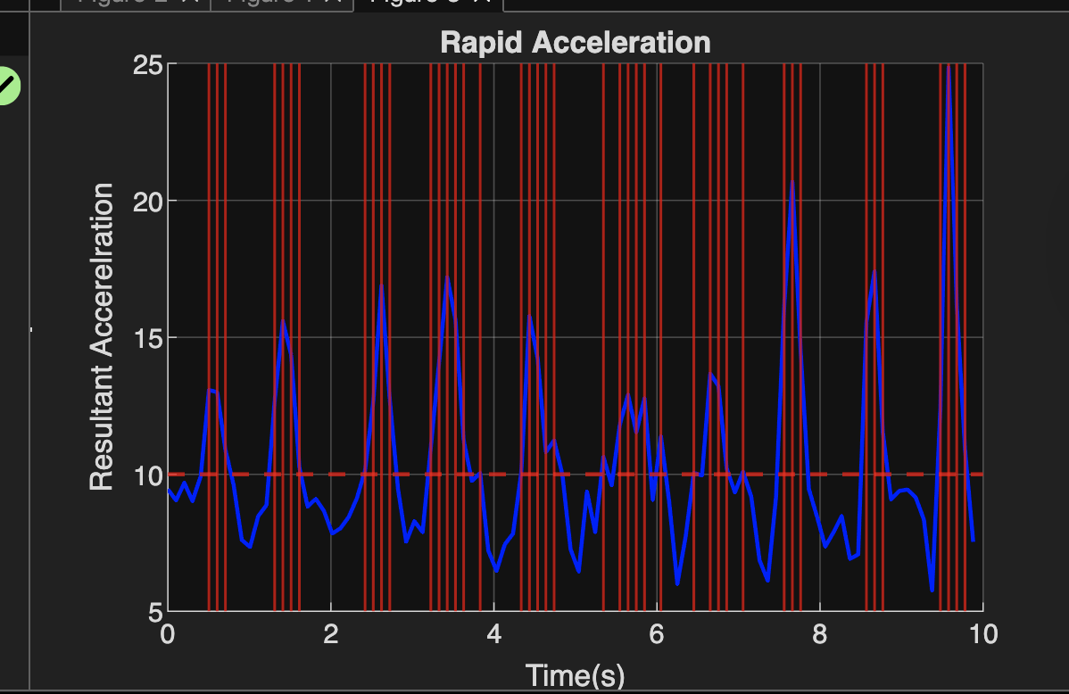

Part B) This question refers to Step 2 in the lab manual. Include below, the annotated plot produced from your partner’s data, and your partner’s name.

Partner:Xiang Chen

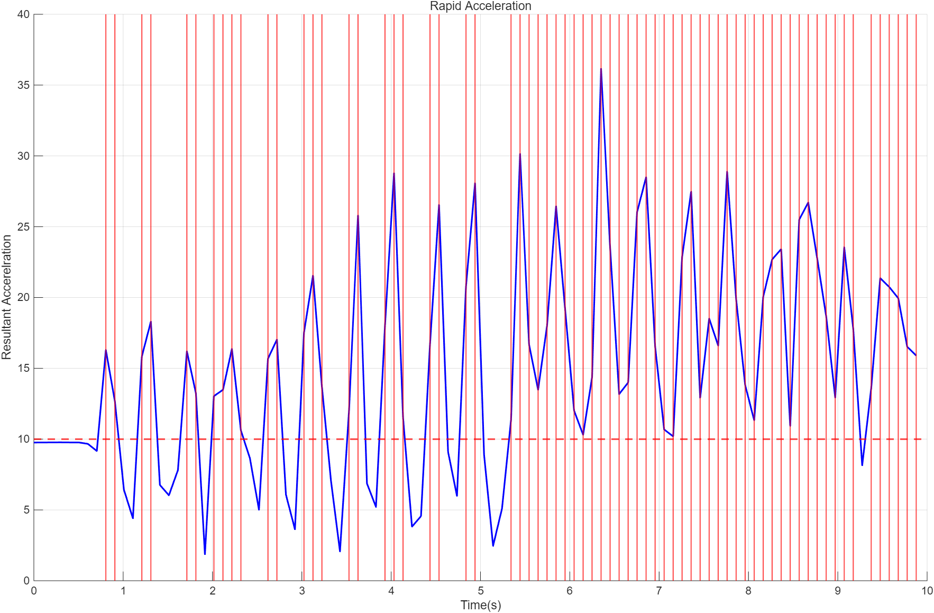

Question 3: AI Reflection
If you used AI for any aspect of your lab, you must complete a short reflection documenting your AI use. You must also attach a log (either as a text log, or screenshots) of your interaction with AI. Your log does not need to be exhaustive, but should provide a reasonable overview of your interaction with the AI: you should include the “important” questions you asked but can omit the complete text of the AI’s response and minor follow up questions. An example is provided on Canvas. Provide 1-3 sentences in answer to the following questions:

- Which AI tool(s) did you use? E.g. cursor, ChatGPT, Gemini, etc…
none

- Describe how you used AI in your lab. E.g. to help with debugging, to suggest ways to improve efficiency/clarity of your code, etc…

- What steps did you take to verify that the responses given to you by the AI were good ones?

Attach chat logs here

